**ASSIGNMENT 2**

**Ria Mittal**

**322010**

**T.E. B - B1**

**TABLE:**

create database abc;  
Query OK, 1 row affected (0.00 sec)  
  
mysql> use abc  
Database changed  
mysql> create table mytable   
 -> ( name varchar(50) , age integer );  
Query OK, 0 rows affected (0.28 sec)  
  
mysql> alter table mytable add address varchar(20);  
Query OK, 0 rows affected (0.56 sec)  
Records: 0 Duplicates: 0 Warnings: 0  
  
mysql> insert into mytable values("ria",20, "pune");  
Query OK, 1 row affected (0.06 sec)  
  
mysql> insert into mytable values("rohit",19, "mumbai");  
Query OK, 1 row affected (0.05 sec)  
  
mysql> insert into mytable values("shashi",20, "sangli");  
Query OK, 1 row affected (0.04 sec)  
  
mysql> insert into mytable values("ankita",20, "dapoli");  
Query OK, 1 row affected (0.03 sec)  
  
mysql> truncate table mytable;  
Query OK, 0 rows affected (0.20 sec)  
  
mysql> select * from mytable;  
Empty set (0.00 sec)  
  
mysql> drop table mytable;  
Query OK, 0 rows affected (0.15 sec)

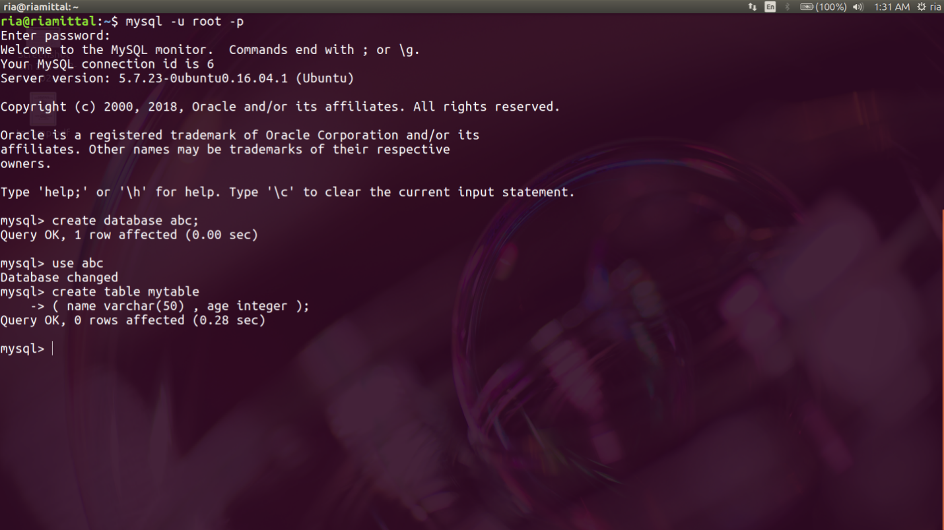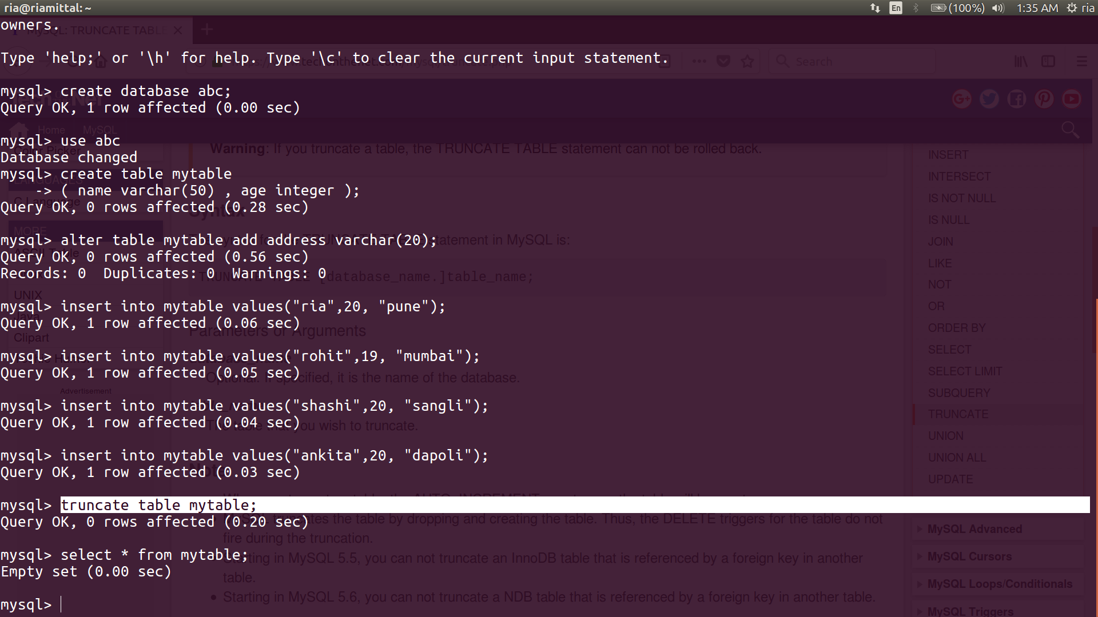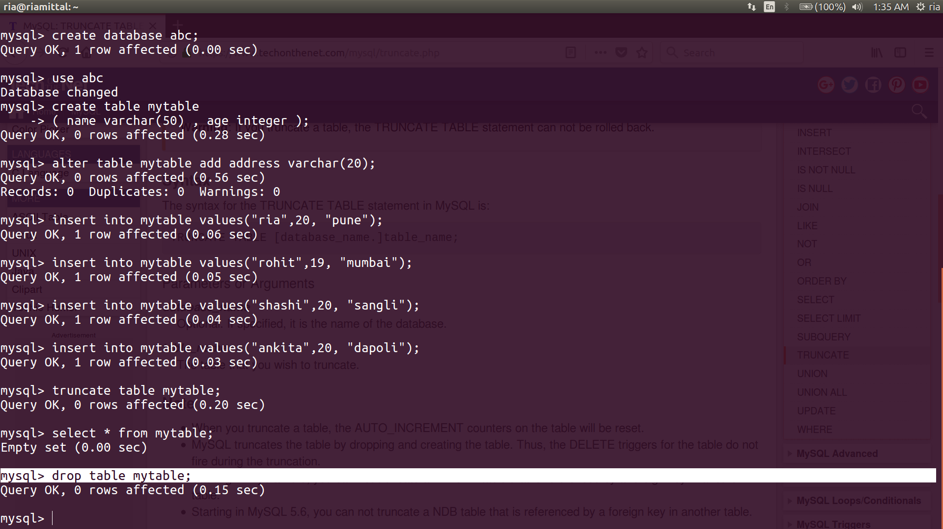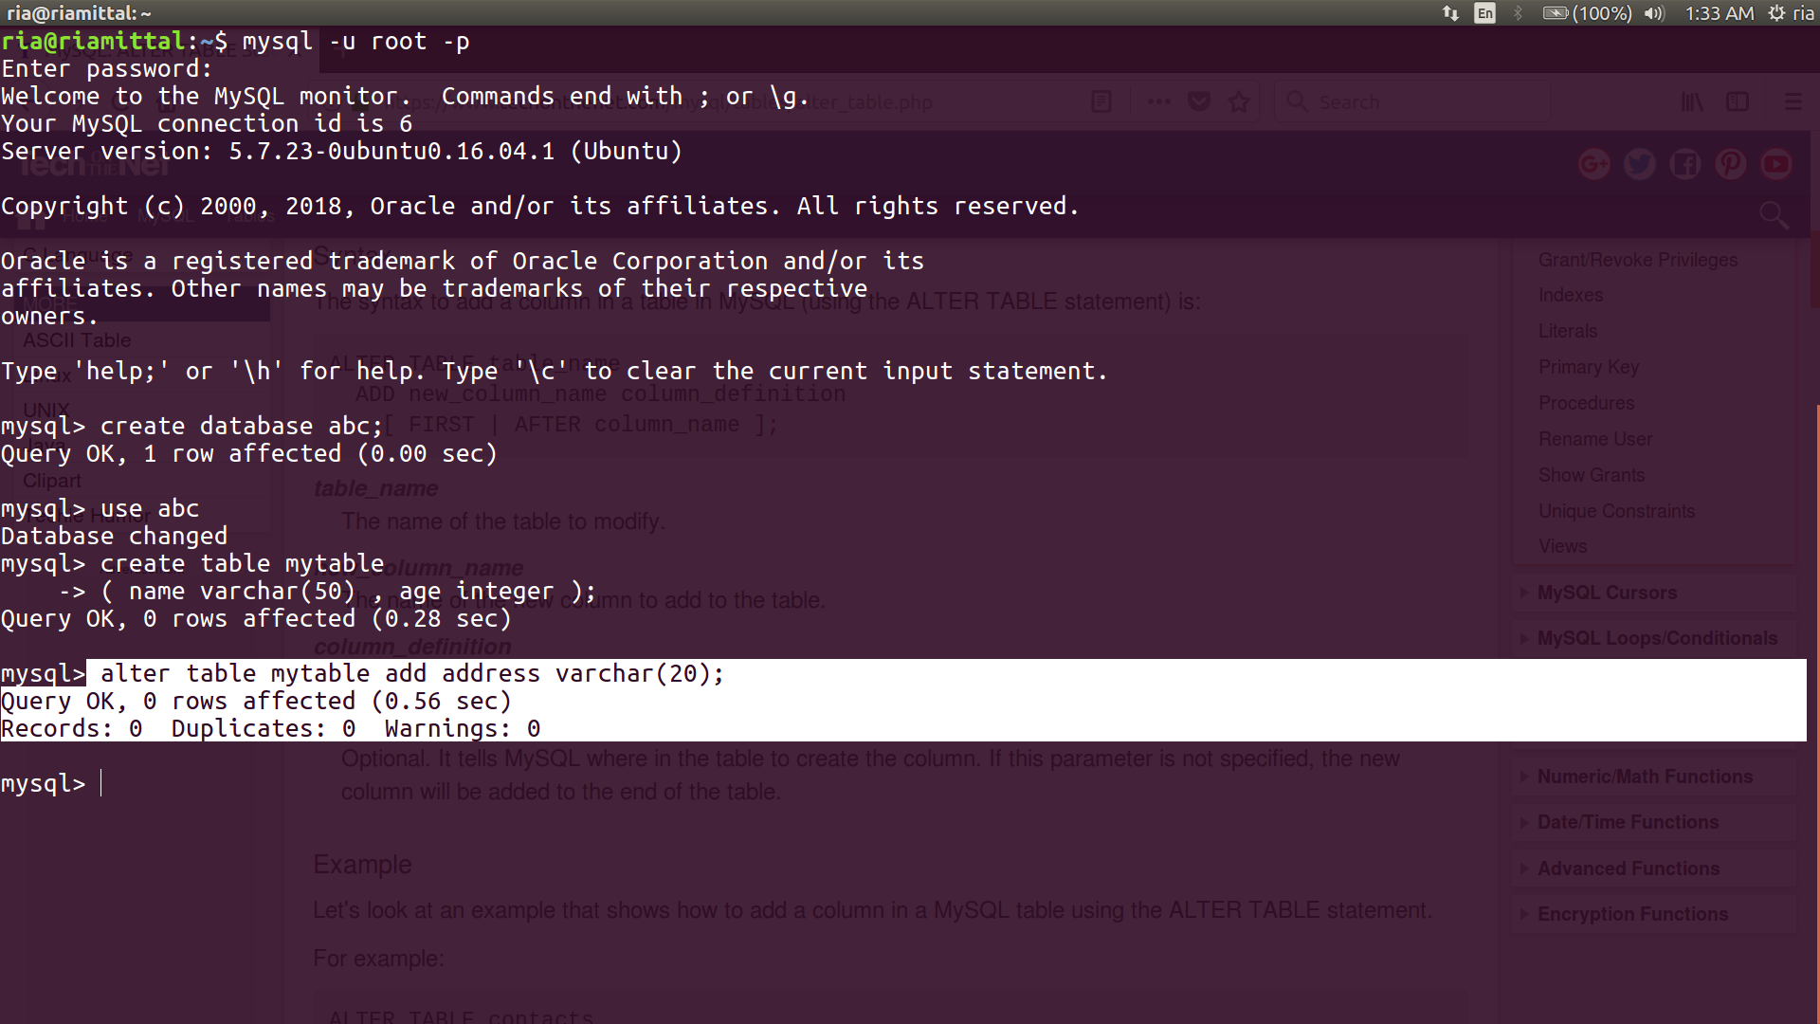

**VIEW:**

select * from tour;

+-----------+-------------+----------+------+---------------+----+

| source | destination | distance | cost | travel_by | id |

+-----------+-------------+----------+------+---------------+----+

| PUNE | MUMBAI | 150 | 2000 | ROAD,RAIL,AIR | 1 |

| PUNE | BENGALURU | 840 | 4000 | ROAD,RAIL,AIR | 2 |

| PUNE | HYDERABAD | 560 | 3000 | ROAD,RAIL,AIR | 3 |

| PUNE | KOLKATA | 1950 | 5000 | RAIL,AIR | 4 |

| PUNE | NEW DELHI | 1450 | 5000 | RAIL,AIR | 5 |

| PUNE | JAIPUR | 1182 | 5000 | RAIL,AIR | 6 |

| MUMBAI | PUNE | 150 | 2000 | ROAD,RAIL,AIR | 7 |

| BENGALURU | PUNE | 840 | 4000 | ROAD,RAIL,AIR | 8 |

| HYDERABAD | PUNE | 560 | 3000 | ROAD,RAIL,AIR | 9 |

| NEW DELHI | PUNE | 1450 | 5000 | RAIL,AIR | 10 |

| JAIPUR | PUNE | 1182 | 5000 | RAIL,AIR | 11 |

| MUMBAI | BENGALURU | 985 | 3000 | ROAD,RAIL,AIR | 12 |

| MUMBAI | HYDERABAD | 710 | 3000 | ROAD,RAIL,AIR | 13 |

| MUMBAI | KOLKATA | 2050 | 5000 | RAIL,AIR | 14 |

| MUMBAI | NEW DELHI | 1410 | 4000 | RAIL,AIR | 15 |

| MUMBAI | JAIPUR | 1160 | 3000 | RAIL,AIR | 16 |

| KOLKATA | PUNE | 1950 | 5000 | RAIL,AIR | 17 |

| NEW DELHI | MUMBAI | 1410 | 4000 | RAIL,AIR | 18 |

| NEW DELHI | JAIPUR | 268 | 1000 | ROAD,RAIL,AIR | 19 |

| NEW DELHI | BENGALURU | 2155 | 4000 | RAIL,AIR | 20 |

| NEW DELHI | HYDERABAD | 1565 | 3500 | RAIL,AIR | 21 |

| NEW DELHI | KOLKATA | 1470 | 3500 | RAIL,AIR | 22 |

| KOLKATA | BENGALURU | 1860 | 3500 | RAIL,AIR | 23 |

| KOLKATA | HYDERABAD | 1490 | 3500 | RAIL,AIR | 24 |

| KOLKATA | JAIPUR | 1510 | 3000 | RAIL,AIR | 25 |

| KOLKATA | MUMBAI | 2050 | 5000 | RAIL,AIR | 26 |

| KOLKATA | MUMBAI | 1470 | 3500 | RAIL,AIR | 27 |

| BENGALURU | MUMBAI | 985 | 3000 | RAIL,AIR | 28 |

| BENGALURU | HYDERABAD | 570 | 1000 | ROAD,RAIL,AIR | 29 |

| BENGALURU | NEW DELHI | 2155 | 4000 | RAIL,AIR | 30 |

+-----------+-------------+----------+------+---------------+----+

30 rows in set (0.00 sec)

mysql> create view places

-> as

-> select source,destination

-> from tour ;

Query OK, 0 rows affected (0.04 sec)

mysql> select * from places;

+-----------+-------------+

| source | destination |

+-----------+-------------+

| PUNE | MUMBAI |

| PUNE | BENGALURU |

| PUNE | HYDERABAD |

| PUNE | KOLKATA |

| PUNE | NEW DELHI |

| PUNE | JAIPUR |

| MUMBAI | PUNE |

| BENGALURU | PUNE |

| HYDERABAD | PUNE |

| NEW DELHI | PUNE |

| JAIPUR | PUNE |

| MUMBAI | BENGALURU |

| MUMBAI | HYDERABAD |

| MUMBAI | KOLKATA |

| MUMBAI | NEW DELHI |

| MUMBAI | JAIPUR |

| KOLKATA | PUNE |

| NEW DELHI | MUMBAI |

| NEW DELHI | JAIPUR |

| NEW DELHI | BENGALURU |

| NEW DELHI | HYDERABAD |

| NEW DELHI | KOLKATA |

| KOLKATA | BENGALURU |

| KOLKATA | HYDERABAD |

| KOLKATA | JAIPUR |

| KOLKATA | MUMBAI |

| KOLKATA | MUMBAI |

| BENGALURU | MUMBAI |

| BENGALURU | HYDERABAD |

| BENGALURU | NEW DELHI |

+-----------+-------------+

30 rows in set (0.00 sec)

mysql> drop view places;

Query OK, 0 rows affected (0.00 sec)

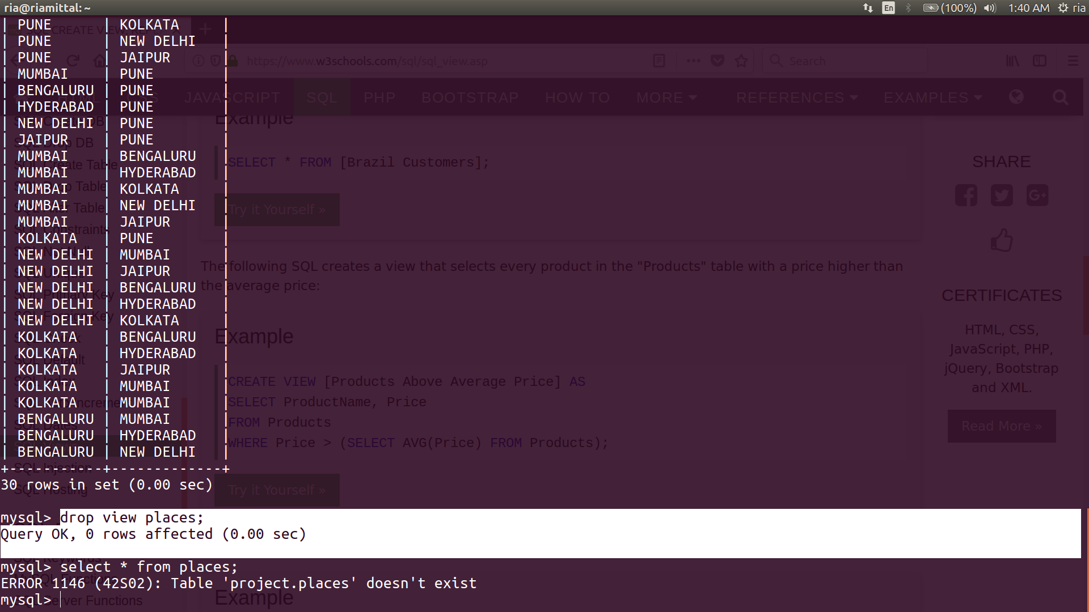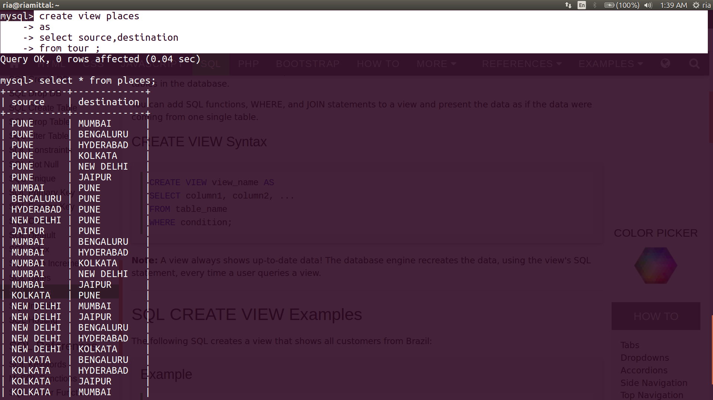

**INDEX:**

create index myindex

mysql-> on tour (source, destination);

Query OK, 0 rows affected (0.29 sec)

Records: 0 Duplicates: 0 Warnings: 0

mysql->alter table tour

-> drop index myindex;

Query OK, 0 rows affected (0.16 sec)

Records: 0 Duplicates: 0 Warnings: 0

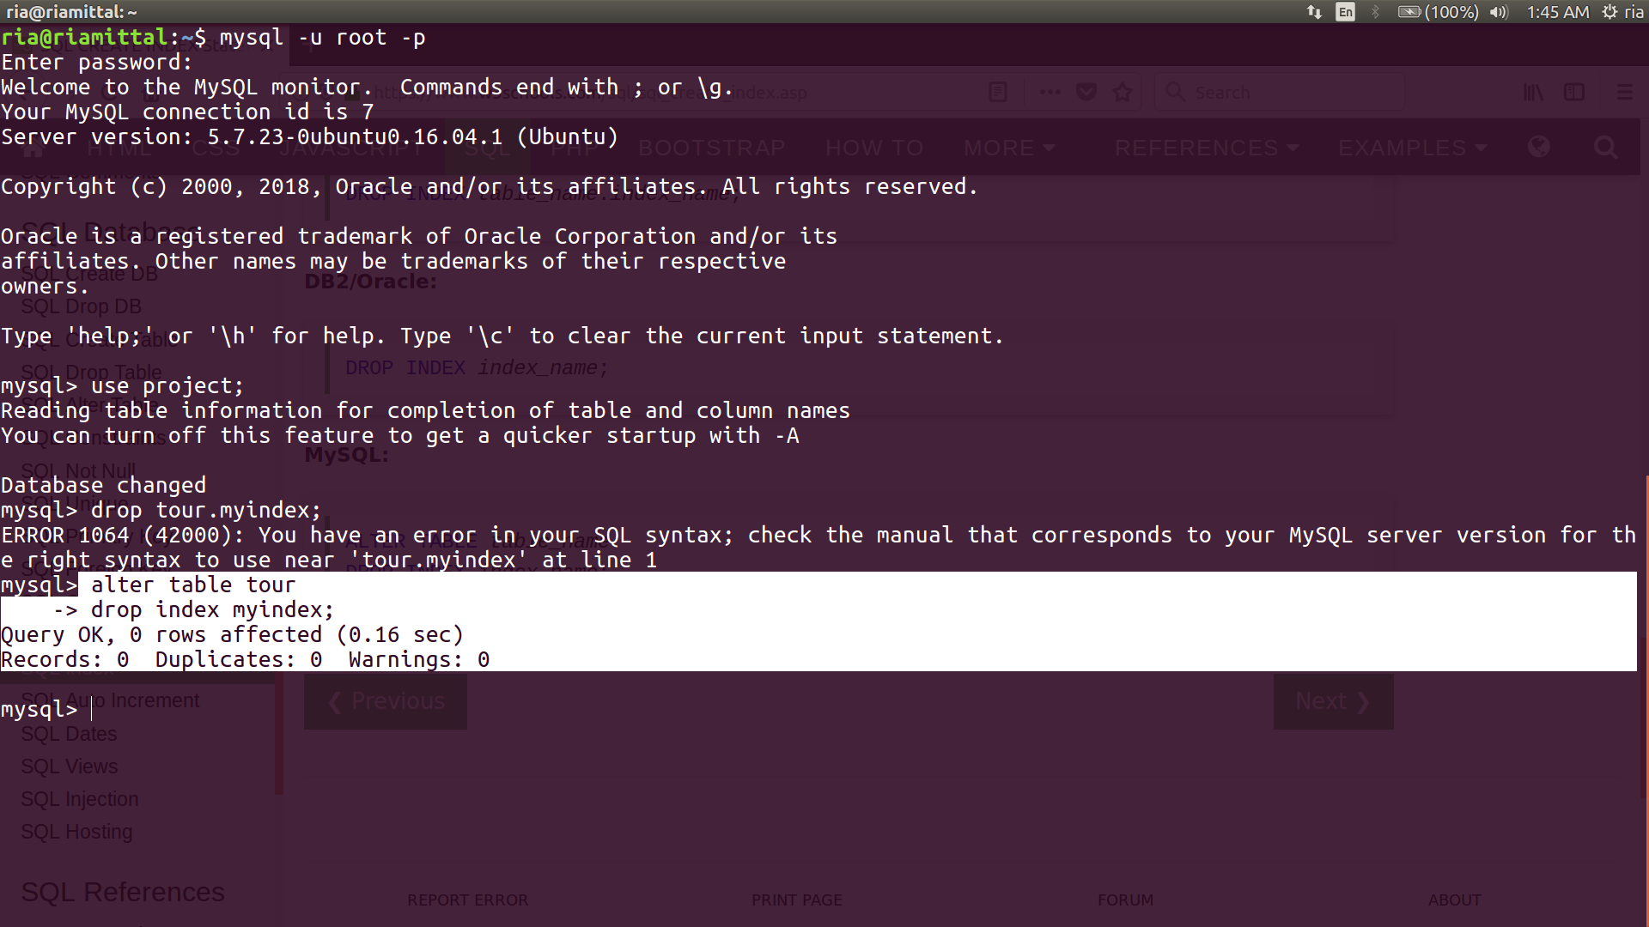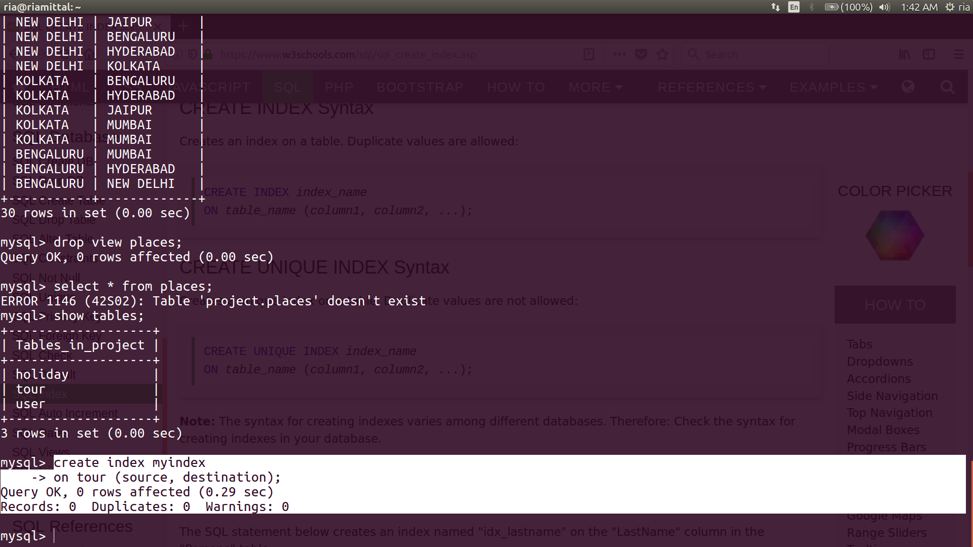

**SEQUENCE:**

Database changed

mysql> create table seq(id int primary key auto_increment, name varchar(10));

Query OK, 0 rows affected (0.26 sec)

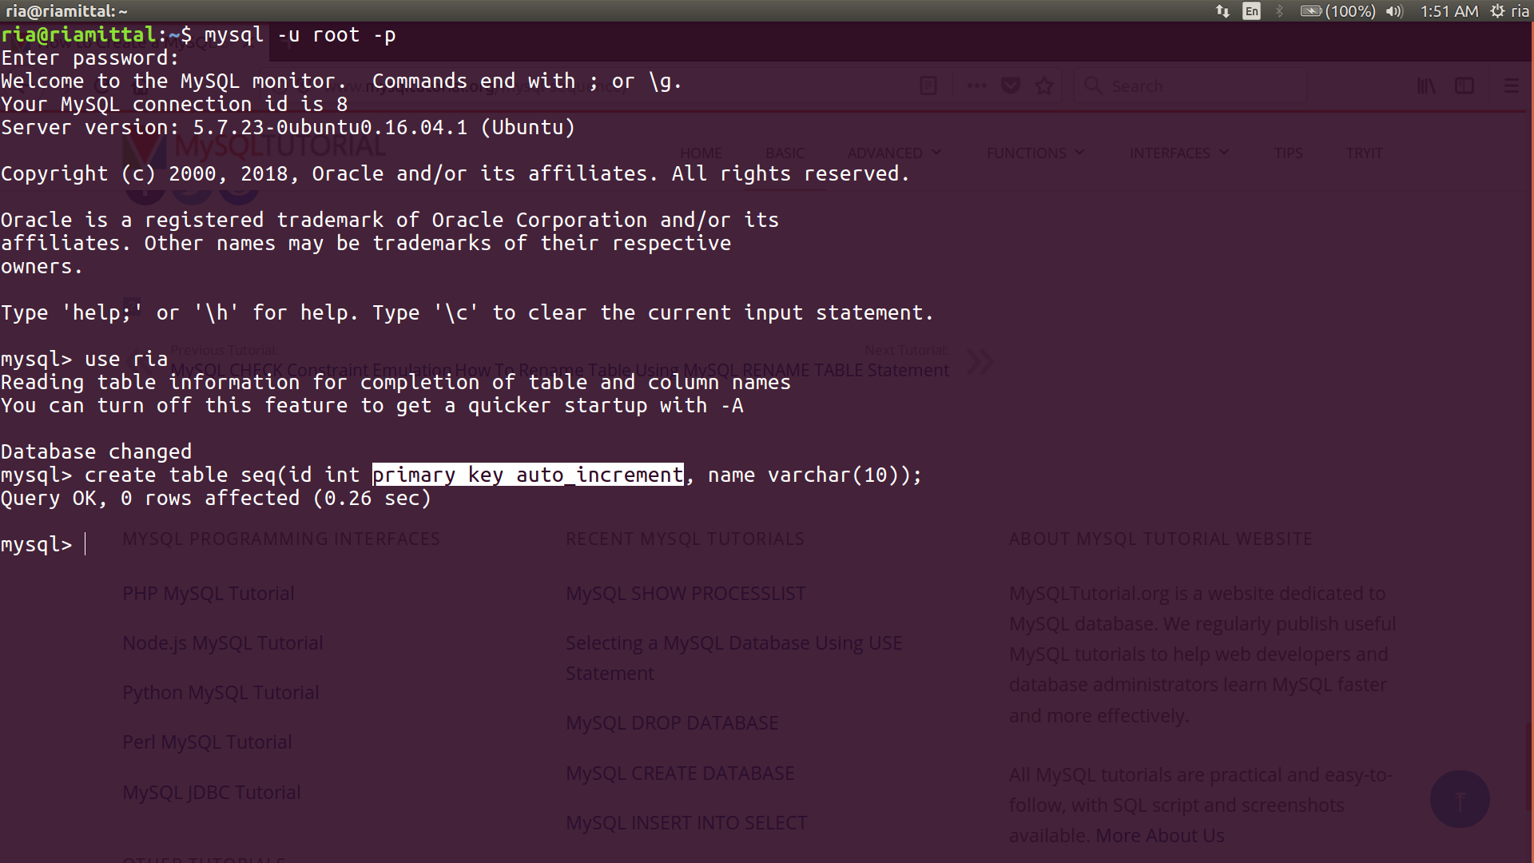

**SYNONYM:**

mysql> CALL sys.create_synonym_db('project','tour');

+----------------------------------------+

| summary |

+----------------------------------------+

| Created 3 views in the `tour` database |

+----------------------------------------+

1 row in set (0.19 sec)

Query OK, 0 rows affected (0.19 sec)

mysql> show full tables from tour;

+----------------+------------+

| Tables_in_tour | Table_type |

+----------------+------------+

| holiday | VIEW |

| tour | VIEW |

| user | VIEW |

+----------------+------------+

3 rows in set (0.00 sec)

